Working with Files and Data Sources
File Formats
- JSON
- Parquet
- ORC Files
Database Connectivity
JDBC
- SQL Server
- MySQL
- PostgreSQL
Reading Data
Hands-on
- Load data from CSV
- Load data from SQL database
- Export to Parquet
- Export to CSV
Advanced Transformations and Joins
Joins
- Inner Join
- Left Join
- Right Join
- Full Join
- Cross Join
Advanced Functions
Window Functions
Ranking
- rank()
- dense_rank()
- row_number()
Aggregations
- rollup()
- cube()
Hands-on — Retail Sales Analytics
- Sales ranking
- Running totals
- Product performance analysis

Working with Files and Data Sources
Working with files & data sources means reading data from different storage formats, processing or analysing it, & writing the results back to storage.
In data engineering & Big Data applications, data may come from files, databases, APIs, cloud storage, or distributed systems.
Typical Workflow
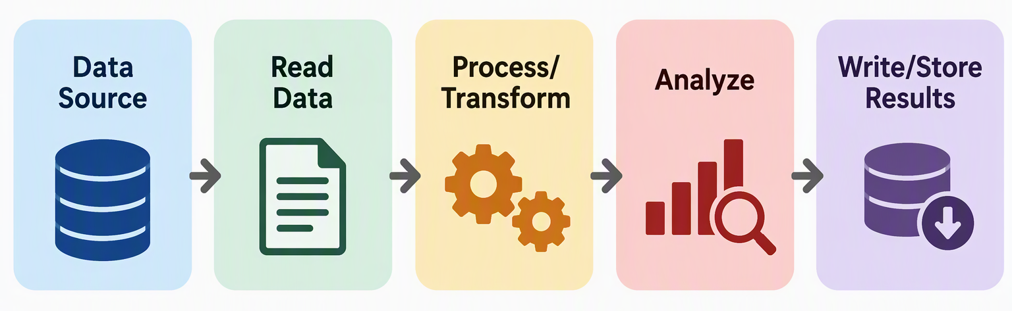
Different file formats are chosen depending on the type of data, storage requirements, performance requirements & tools being used.
File Formats
- JSON – Text based format used to represent structured & semi-structured data. It stores information using Key-Value Pairs.
Characteristics of JSON
  - Human-Readable
  - Text-Based
  - Flexible
  - Platform independent
  - Suitable for structured & semi-structured information
  - Capable of representing nested data
Common uses of JSON
  - REST API responses
  - Application configuration
  - Web application
  - NoSQL databases
  - Data Exchange between systems
  - Event & log data
  - Semi-structured datasets
- Parquet – Apache Parquet is a columnar binary file format designed for efficient storage & analysis of large datasets.
Why Columnar Storage Matters?
Suppose a dataset consists of 100 columns. But a report only requires:
Department Name, Salary.
This can reduce:
  - Data read from storage
  - DISK/IO
  - Processing time
  - Memory requirements
Schema Support
Parquet stores schema information with the data.
This makes Parquet convenient for analytical systems because the structure & types of the data are preserved.
Compression
Parquet provides efficient compression because similar values are stored together within columns.
Common uses
- Big Data Analytics
- Apache Spark
- Data Lakes
- Data Engineering Pipelines
- Cloud Analytics
- Machine-leaning datasets
- Large historical datasets
- ORC Files – Optimized Row Columnar is the file format designed for efficient storage & processing of large datasets.
It is commonly associated with the Hadoop ecosystems & particularly well integrated with technologies such as Apache Hive, Apache Spark.
ORC Storage Concept
Like Parquet, ORC organizes information so analytical systems can efficiently access the required columns.
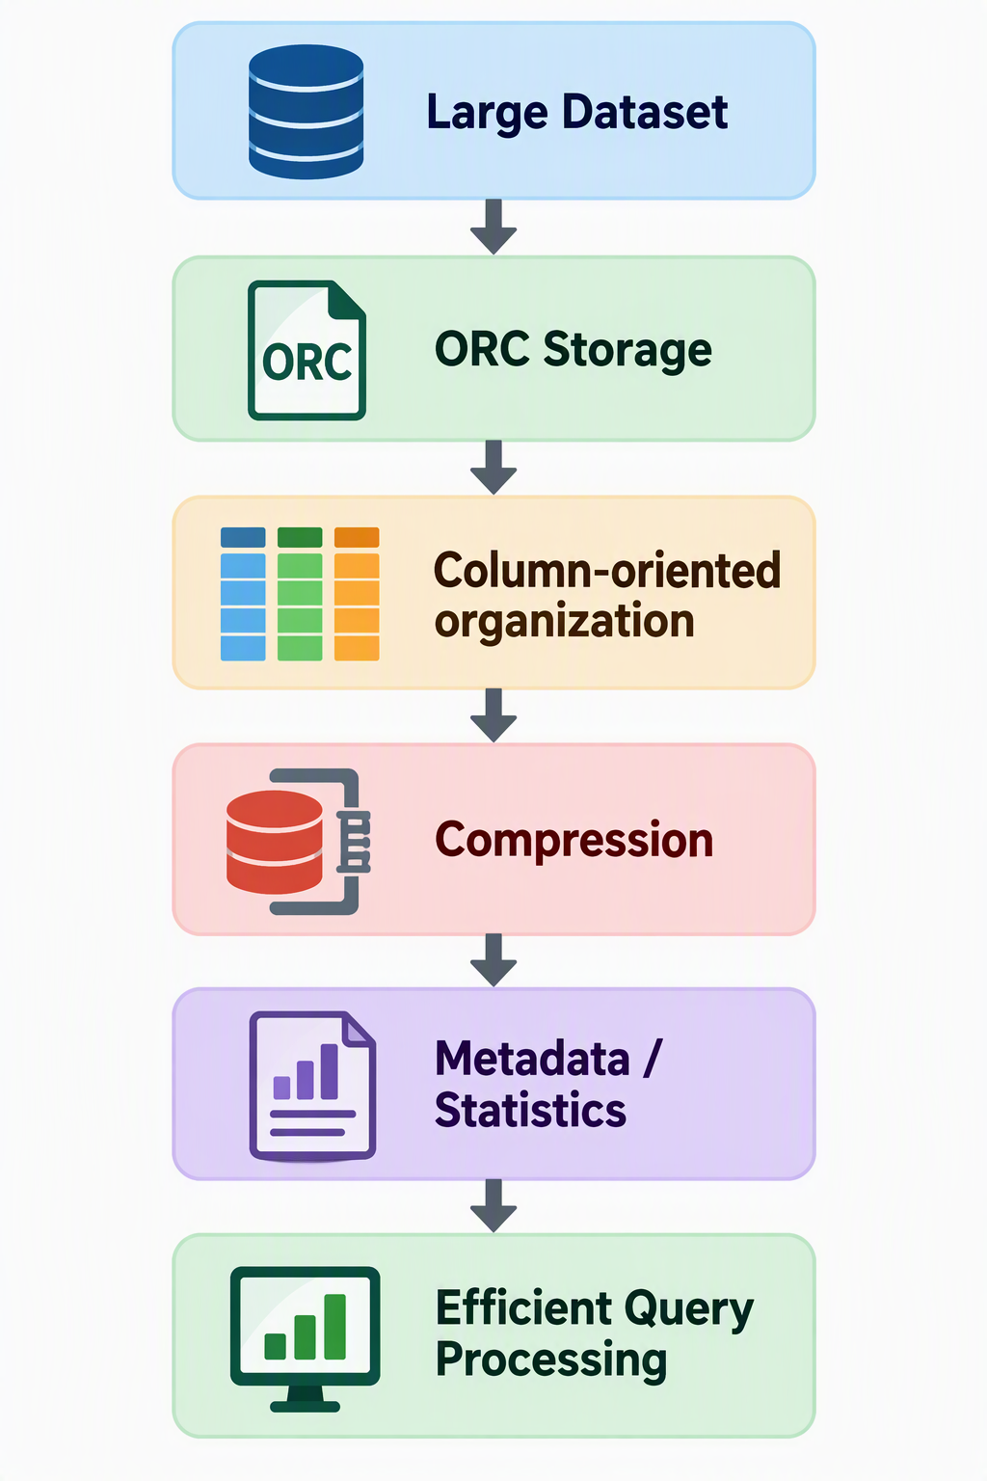
ORC Stripes
ORC files are divided into large, logical units called stripes where a stripe contains column data along with metadata & indexes/statistics that help processing engines determine which data needs to be read.
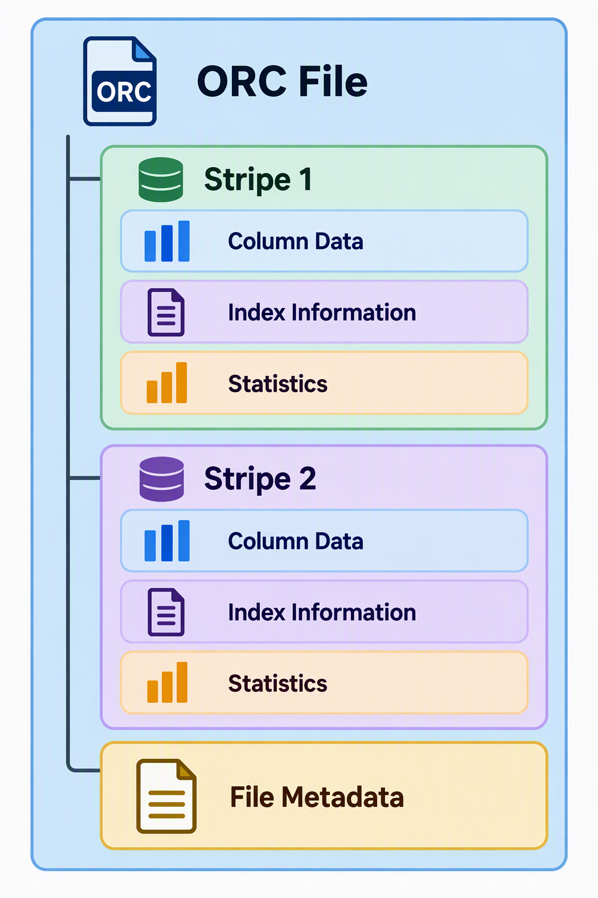
Predicate Pushdown
An important optimization in columnar formats.
Common Uses
- Hadoop-based systems
- Apache Hive
- Apache Spark
- Large analytical datasets
- Data Warehouses
- Data Lakes
- Batch Processing
JSON vs Parquet vs ORC
Feature | JSON | Parquet | ORC
Format | Text | Binary | Binary
Storage style | Document/record-oriented | Columnar | Columnar
Human readable | Yes | No | No
Schema support | Flexible/self-describing structure | Strong | Strong
Compression efficiency | Generally lower | High | High
Analytical performance | Generally lower | High | High
Nested data | Excellent | Supported | Supported
Big Data analytics | Possible | Excellent | Excellent
Spark support | Yes | Yes | Yes
Common use | APIs/data exchange | Analytics/data lakes | Hadoop/Hive analytics

Database Connectivity
Database Connectivity is the process of connecting Apache Spark to an external database so that Spark can read data from the database, process it using distributed computing, & optionally write processed results back.
Organizations commonly store operational data in relational database such as SQL Server, MySQL, PostgreSQL, etc. Spark can connect to these databases using JDBC.
JDBC
What is JDBC?
Java Database Connectivity is a standard technology used by Java-based applications to communicate with relational databases.
Because Apache Spark runs on the JVM, JDBC provides a common way for Spark to connect to many relational database systems.
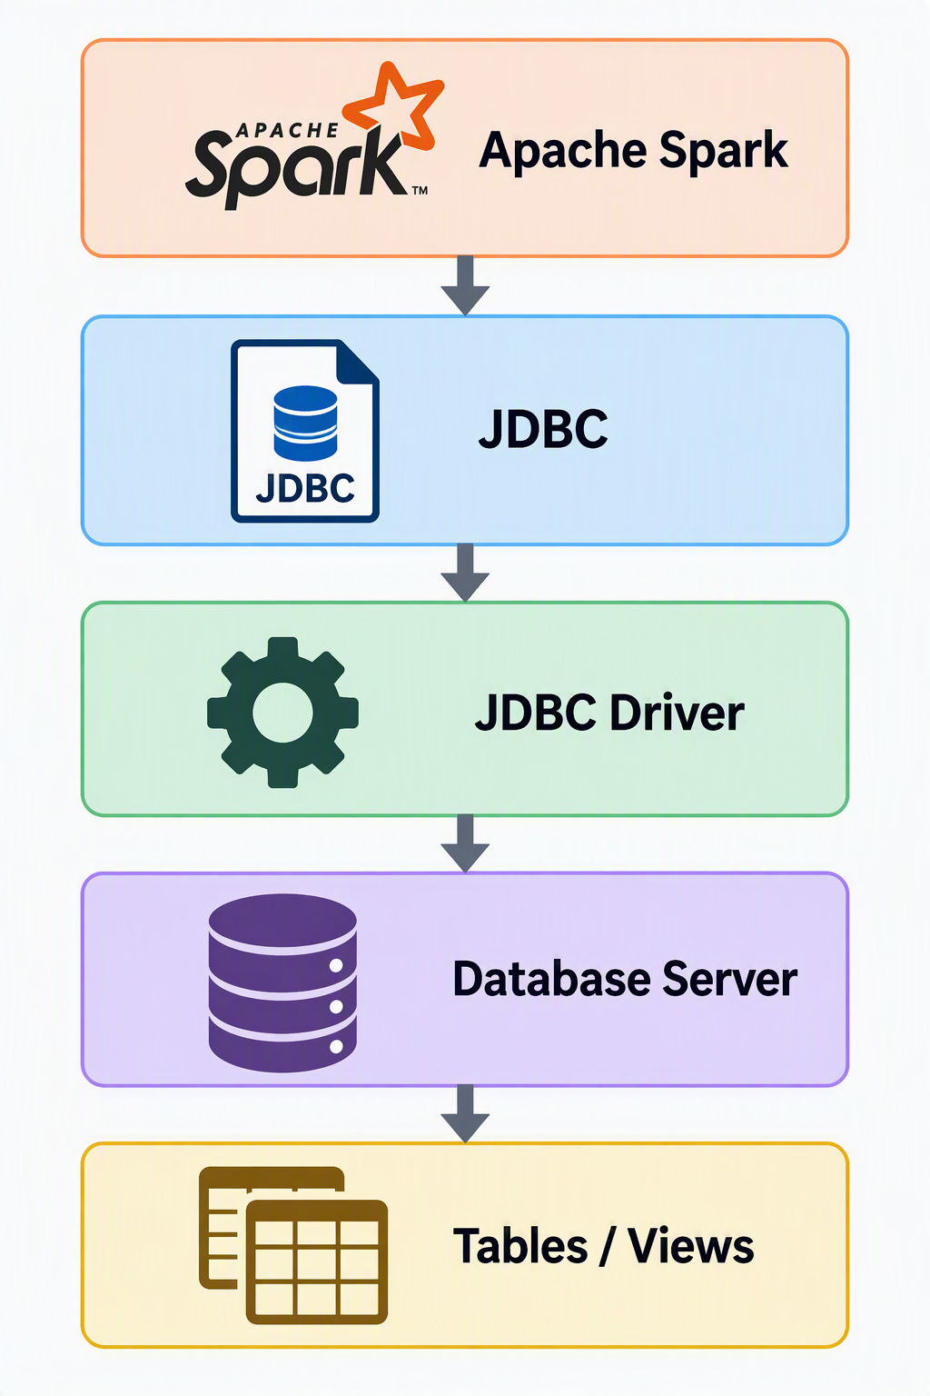
Components required for JDBC connectivity
Component | Purpose
Database Server | Machine/service hosting the database
Database Name | Database to access
Port | Network port used by the database
JDBC URL | Connection address
JDBC Driver | Enables communication with the database
Username | Authentication
Password | Authentication
Table/View | Data source to read

- SQL Server
- MySQL
- PostgreSQL
Reading Data
Hands-on
- Load data from CSV
- Load data from SQL database
- Export to Parquet
- Export to CSV
Advanced Transformations and Joins
Joins
- Inner Join
- Left Join
- Right Join
- Full Join
- Cross Join
Advanced Functions
Window Functions
Ranking
- rank()
- dense_rank()
- row_number()
Aggregations
- rollup()
- cube()
Hands-on — Retail Sales Analytics
- Sales ranking
- Running totals
- Product performance analysis

